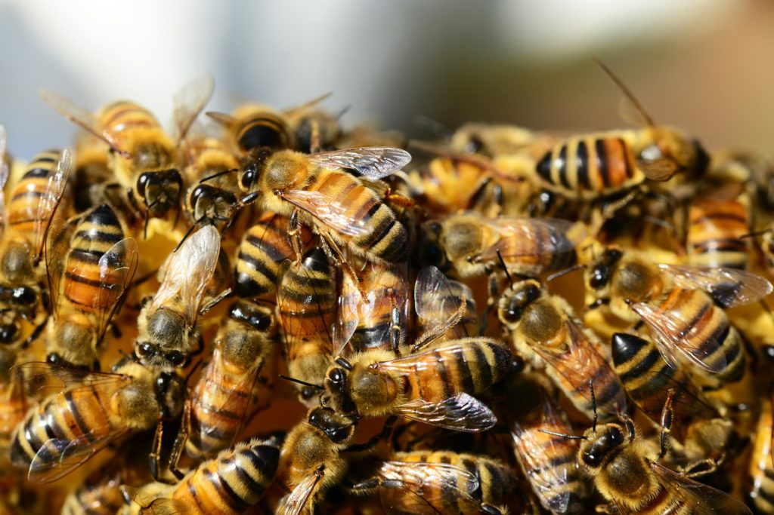
30 Interesting Facts About Bees That Will Surprise You!
- Bees use the sun as a compass and on cloudy days they use polarized light to find their way.
- Due to colony collapse disorder, bees have been dying at a rate of 30% per year.
- Honey is composed of 80% sugar and 20% water.
- Honeybees are the only type of bee that dies after stinging.
- Beekeeper’s suit is always white because bees react strongly to dark colors.
- Bees use a sticky substance gathered from the buds of trees called propolis, in order to fill in the cracks and waterproof their hives.
- Bees have four stages of life: egg, larvae, pupae and adult.
- Only female bees have stingers.
- During the winter some of the worker-bees only have the job to vibrate and heat the hive in order to keep it to the optimal temperature.
- Bees have existed for around 30 million years.
- Newborn bees ask for food by sticking out their tongues at passing worker bees.
- Every bee colony has its own particular scent in order for the colony members to identify each other.
- Every bee has two stomachs – one for eating and one for storing nectar.
- In the USA more than 300 different kinds of honey are produced every year and the variety of color and flavor depends on the types of flowers from which the bees collect nectar.
- A worker bee can carry nectar or pollen to 80% of its own body weight.
- A queen can survive stinging, unlike the worker bees which die after stinging.
- “Honeymoon” originates from the ancient tradition of supplying a newlywed couple with a month’s supply of honey in order to ensure happiness and fertility.
- Every species of bee performs their communication dances differently.
- Using beeswax people make many products that we use every day: medicine, cosmetics and furniture polishes.
- Drones die after mating with a queen.
- Honeybees do not know how to make honey when they are born. Older bees in the hives teach them how to make it.
- Honeybees are the only insects that produce food that people consume.
- The darker the honey, the greater amount of antioxidant properties it has.
- People use bee venom as a treatment for arthritis and high blood pressure.
- A productive queen can lay up to 2.500 eggs per day.
- Bees communicate in two ways: with the use of pheromones and with the waggle dance.
- Bees have 5 eyes: 3 simple and 2 compound eyes.
- Honeybees’ sense of smell is 50 times more powerful than a dog’s, as they have 170 smell receptors.
- For every pound of honey produced, one hive must collect 10 pounds of pollen.
- Bees make their honey by regurgitating digested nectar into honeycomb cells and then fanning it with their wings.

